Proof of Concept (POC)
Enterprise Conversational AI Assistant

- POC Objective :
Demonstrate the feasibility, reliability, and control of an enterprise conversational AI assistant capable of answering complex domain-specific questions using trusted internal knowledge sources, while preventing hallucinations and uncontrolled responses.
This POC validates:
- Technical architecture
- AI governance & control
- Integration capability
- User experience feasibility
- Business Problem :
Enterprise users frequently struggle to:
- Understand complex procedural documents (PDFs, regulations, internal guides)
- Locate precise, up-to-date information quickly
- Avoid inconsistent or incorrect interpretations
Traditional search tools fail to provide contextual, conversational, and explainable answers.
- Proposed Solution (POC Scope) :
A controlled conversational AI chatbot that:
- Uses Rasa for intent recognition and dialogue orchestration
- Uses an LLM for reasoning and natural language generation
- Is strictly grounded in enterprise knowledge (PDFs / structured data)
- Refuses to answer when information is missing or out of scope
This POC is intentionally limited in scope to ensure reliability.
- POC Architecture (High Level) :
- Road Map :
Component | Technology Choice | Description
Natural Language Processing (NLP) Engine | Hugging Face Transformers | Perfect for custom QA, intent classification, and semantic search.
Intent Manager | Rasa | Great for dialogue management and NLU (optional if you go full QA).
AI Orchestration Layer | LangChain | Coordinates LLM calls, prompt templates, retrieval pipelines, and integrates vector search with the LLM (RAG architecture).
Custom Action Server | Sanic | Business Logic and Orchestration
Large Language Model (LLM) | Phi-3 | fallback to it for complex queries and generic answers if no intent or match found.
Vector Search | FAISS | Needed for deep search from previous Q&A or knowledge base.
Python Microservice | FastAPI | Best choice for ML/NLP serving and inference.
Dependency Injection | FastAPI | Injects services (NLP, DB) into endpoints without manual instantiation.
Circuit Breaker | Error Handling CircuitBreakerError | Catches error kind and utters circuit_opened_alert
Backend | Spring Boot  (API Layer) | Great for auth, student profiles, session logging, etc.
Frontend | React JS - WebChat | Flexible, beautiful, and user-friendly.
Training Storage | PostgreSQL | Robust choice for storing questions, sessions, logs.
Table 1. ChatBot Architecture

- Class Diagram :
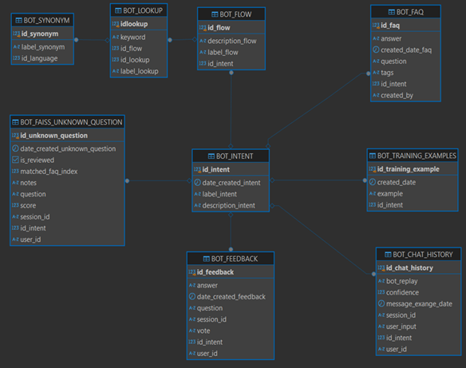
Figure 1. Class Diagram
- Architecture :
Key Architectural Principles
- LLM is NOT autonomous
- Rasa controls the conversation
- All answers are grounded
- No free-text generation without context


User [WebChat]


- WitespaceTokenizer
- RegexEntityExtractor
- DIETClassifier
- EntitySynonymMapper
- FallbackClassifier
RASA NLU
ddd

Config.yml


- MemorizationPolicy
- RulePolicy
- TEDPolicy
RASA Core
Policies

Custom Actions

Action Server : endpoint.py (sanic)
/webhook
ActionExecuter
RegexActions : DI



LLM based
Actions (Phi-3)
LangChain
Semantic Action
Spring Boot
based Actions

- FAISS Semantic Ranking
- Weighted answer picking
- Call LLM Server
- Generate Responses
- AI Orchestration Layer
- Progressive Disclosure
- Fallback Action
- Forwarded Intent

✅ Handled Responses
❌Centralized Handling Errors

👍 👎

Feedback

Figure 2. Architecture Diagram : Hybrid Architecture

- POC Functional Capabilities :
✅ Supported Capabilities | ❌ Explicitly Out of Scope
- Answer questions based on official Markdown, PDF, JSON, TEXT contents  - Explain hierarchical structures and procedures  - Provide concise and precise answers  - Handle follow-up clarification requests  - Safely refuse unsupported question | - Open-domain knowledge  - Opinions or speculation  - Answers outside validated sources
Table 2. ChatBot Functional Capabilities

- POC Demonstration Scenarios :
🎯 Scenario 1: Grounded Question Answering
User:
“Donner moi la hiérarchie de Composante 2
Bot Behavior:
- Extracts content from Markdown Table
- Generates the structure
- Uses formal and controlled language
✔ No hallucination
✔ No invented content
🎯 Scenario 2: Clarification Request
User:
“Est ce que Production RDI se déroule à distance ou en présentiel”
Bot Behavior:
- Get PDF Context and responds basing on it
- Expands explanation without adding new concepts
- Maintains consistency
✔ Context continuity
✔ Controlled expansion
🎯 Scenario 3: Out-of-Scope Question
User:
“What do you think about changing the evaluation rules?”
Bot Response:
“I’m unable to answer this question because it falls outside the validated reference content.”
✔ Safe refusal
✔ Governance demonstrated
- Non-Functional Validation (What Leaders Care About) :
Area | Validation
Security | No external data exposure
AI Control | No autonomous reasoning
Explainability | Answers traceable to sources
Performance | Sub-second response time
Scalability | Stateless services, API-based
Maintainability | Modular Rasa actions
Tableau 3. ChatBot Non-Functional validation

- Success Criteria :
The POC is considered successful if:
- The chatbot answers correctly without hallucination
- Incorrect questions are safely rejected
- The architecture supports future scaling
- Technical stakeholders validate feasibility
- Demonstration Requests Dates :
23-02-2026

22-01-2026

🤖 17 Sprints
17-10-2025
22-07-2025

19-07-2025

- Next Steps After POC :
🚀 Future RoadMap :
- Integrate NVIDIA
- Improve design
- Lanch Test in DSI members
- Implement documentation
- Implement Admin Dashboard
- Extend knowledge sources
- Add multilingual support (EN / AR)
- Introduce analytics & monitoring
- Add Phone Message Notification
- Intregrate MFA
- Add vocal mode

